CS 499 Module One Assignment – Lilly Bryan

Complete this template by replacing the bracketed text with the relevant information.

- Self-Introduction: Address all of the following questions to introduce yourself.

  - How long have you been in the Computer Science program?
I have been in the Computer Science program for 2 years.

  - What have you learned while in the program? List three of the most important concepts or skills you have learned.
I have learned how to research and problem solve to create projects and fix errors in new and preexisting systems.

  - Discuss the specific skills you aim to demonstrate through your enhancements to reach each of the course outcomes.
I aim to demonstrate my skills of problem solving skills to improve on existing code. I also plan to demonstrate my design skills as well.

  - How do the specific skills you will demonstrate align with your career plans related to your degree?
Coding, problem solving, and design skills all relate to my career plan as my goal is to become a indie game developer.

  - How does this contribute to the specialization you are targeting for your career?
These skills will allow me to create and improve on projects I make outside of my degree.

- ePortfolio Set Up:

  - Submit a screen capture of your ePortfolio GitHub Pages home page that clearly shows your URL.
    - You already have a repository in GitHub where you uploaded projects in previous courses. Your ePortfolio will reside in GitHub but can link to work at other sites, such as Bitbucket.

  - Use the GitHub Pages link in the Resource section for directions on:
    - How to create your GitHub website and publish code to GitHub Pages
    - Issues, such as adding links to other sites

  - Paste a screenshot of your GitHub Pages home page with your URL clearly showing in the space below.
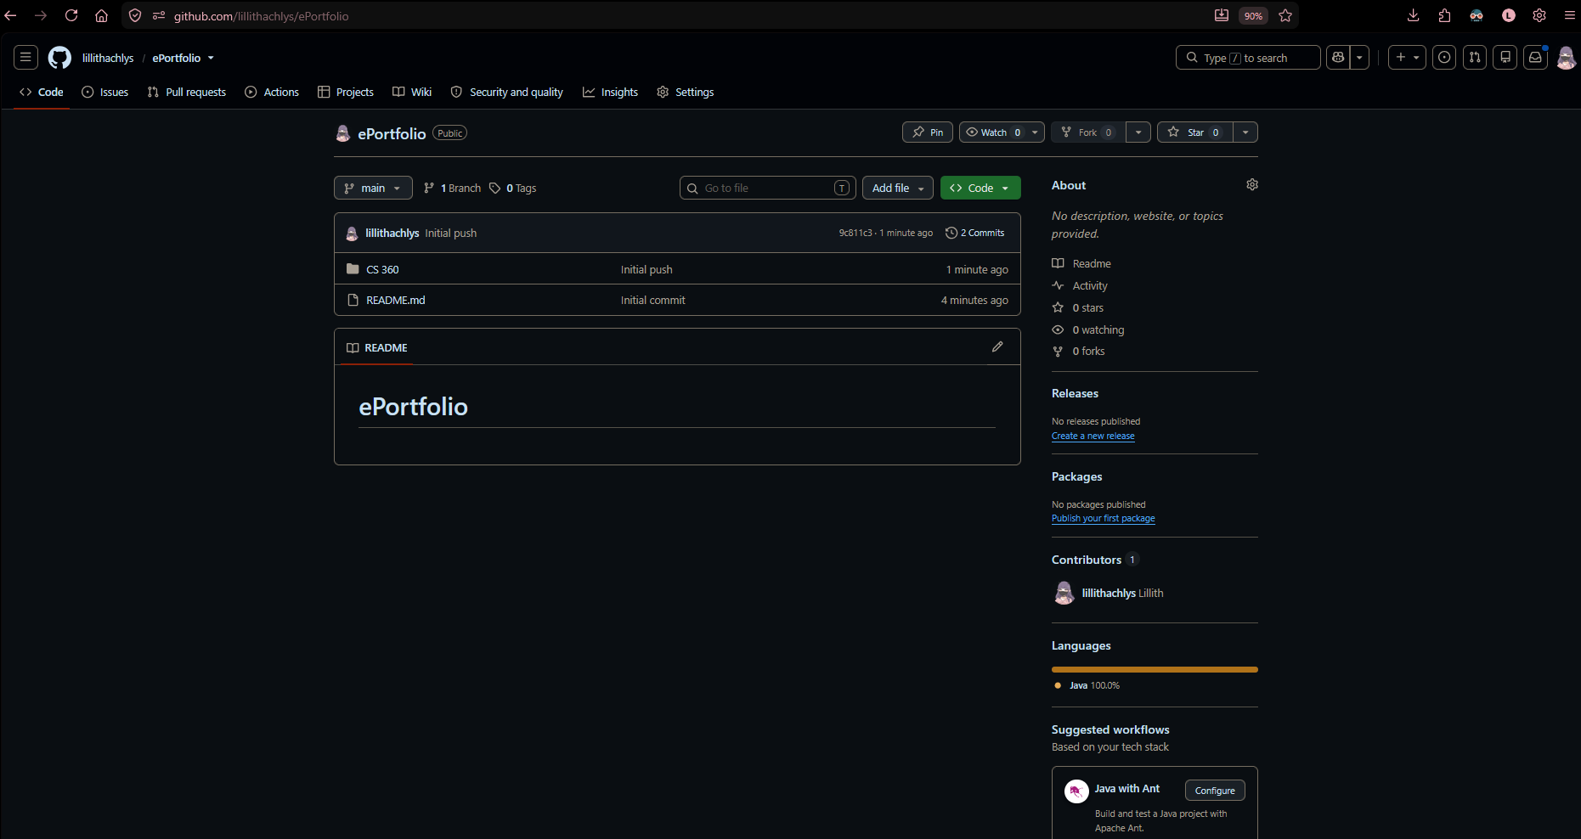

- Enhancement Plan:

  - Category One: Software Engineering and Design
    - Select an artifact that is aligned with the software engineering and design category and explain its origin. Submit a file containing the code for the artifact you choose with your enhancement plan.

CS 360

Note: Your artifact may be work from the following courses:

- IT 145: Foundation in Application Development
- CS 250: Software Development Lifecycle
- CS 260: Data Structures and Algorithms
- IT 315: Object Oriented Analysis and Design
- CS 320: Software Testing, Automation, and Quality Assurance
- CS 330: Computational Graphics and Visualization
- CS 340: Advanced Programming Concepts
- CS 350: Emerging Systems Architectures and Technologies
- CS 360: Mobile Architecture and Programming
- IT 365: Operating Environments
- IT 380: Cybersecurity and Information Assurance
- CS 405: Secure Coding
- CS 410: Reverse Software engineering
- IT 340: Network and Telecommunication Management
- IT 380: Cybersecurity and Information Assurance

    - Describe a practical, well-illustrated plan for enhancement in alignment with the category, including a pseudocode or flowchart that illustrates the planned enhancement.

I plan on improving the overall design of the projects, as well as improving the overall functionality. One main function I would like to add is a weight goal planner that will show the user an estimated flow chart and time frame for their weight goal based on their weight and average calorie count.

For this category of enhancement, consider improving a piece of software, transferring a project into a different language, reverse engineering a piece of software for a different operating system, or expanding a project’s complexity. These are just recommendations. Consider being creative and proposing an alternative enhancement to your instructor.

Think about what additions to include to complete the enhancement criteria in this category. Since one example option is to port to a new language, that is the kind of scale that is expected. This does not mean you need to port to a new language but instead have an equivalent scale of enhancement. Underlying expectations of any enhancement include fixing errors, debugging, and cleaning up comments, but these are not enhancements themselves.

    - Explain how the planned enhancement will demonstrate specific skills and align with course outcomes.

      - Identify and describe the specific skills you will demonstrate that align with the course outcome.

I will demonstrate my design patterns, UI/UX optimization, and modular programming skills.

      - Select one or more of the course outcomes below that your enhancement will align with.

3 and 4

Course Outcomes:

- Employ strategies for building collaborative environments that enable diverse audiences to support organizational decision-making in the field of computer science.
- Design, develop, and deliver professional-quality oral, written, and visual communications that are coherent, technically sound, and appropriately adapted to specific audiences and contexts.
- Design and evaluate computing solutions that solve a given problem using algorithmic principles and computer science practices and standards appropriate to its solution while managing the trade-offs involved in design choices.
- Demonstrate an ability to use well-founded and innovative techniques, skills, and tools in computing practices for the purpose of implementing computer solutions that deliver value and accomplish industry-specific goals.
- Develop a security mindset that anticipates adversarial exploits in software architecture and designs to expose potential vulnerabilities, mitigate design flaws, and ensure privacy and enhanced security of data and resources.

  - Category Two: Algorithms and Data Structures

- Select an artifact that is aligned with the algorithms and data structures category and explain its origin. Submit a file containing the code for the artifact you choose with your enhancement plan. You may choose work from the courses listed under Category One.

CS 360

- Describe a practical, well-illustrated plan for enhancement in alignment with the category, including a pseudocode or flowchart that illustrates the planned enhancement.

I plan on improving the data structures from this project. Mainly with reworking and expanding on the user’s data.

For this category of enhancement, consider improving the efficiency of a project or expanding the complexity of the use of data structures and algorithms for your artifact. These are just recommendations. Consider being creative and proposing an alternative enhancement to your instructor. Note: You only need to choose one type of enhancement per category.

Think about what additions to include to complete the enhancement criteria in this category. Since one example option is to port to a new language, that is the kind of scale that is expected. Perhaps you might increase the efficiency and time complexity of an algorithm in an application and detail the logic of the increased time complexity. Remember, you do not need to port to a new language but instead have an equivalent scale of enhancement. Underlying expectations of any enhancement include fixing errors, debugging, and cleaning up comments, but these are not enhancements themselves.

- Explain how the planned enhancement will demonstrate specific skills and align with course outcomes.

  - Identify and describe the specific skills you will demonstrate to align with the course outcome.

I will demonstrate data structure optimization by replacing basic inefficient storage types with collections to track historical progress.

  - Select one or more of the course outcomes listed under Category One that your enhancement will align with.

1, 3, and 5

  - Category Three: Databases

    - Select an artifact that is aligned with the databases category and explain its origin. Submit a file containing the code for the artifact you choose with your enhancement plan. You may choose work from the courses listed under Category One.

CS 360

    - Describe a practical, well-illustrated plan for enhancement in alignment with the category, including a pseudocode or flowchart that illustrates the planned enhancement.

I plan to expand on the database and allow for more information to be saved for user’s, including a calorie counter.

For this category of enhancement, consider adding more advanced concepts of MySQL, incorporating data mining, creating a MongoDB interface with HTML/JavaScript, or building a full stack with a different programming language for your artifact. These are just recommendations; consider being creative and proposing an alternative enhancement to your instructor. Note: You only need to choose one type of enhancement per category.

Think about what additions to include to complete the enhancement criteria in this category. Since one example option is to port to a new language, that is the kind of scale that is expected. Perhaps you might increase the efficiency and time complexity of an algorithm in an application and detail the logic of the increased time complexity. Remember, you do not need to port to a new language but instead have an equivalent scale of enhancement. Underlying expectations of any enhancement include fixing errors, debugging, and cleaning up comments, but these are not enhancements themselves.
    - Explain how the planned enhancement will demonstrate specific skills and align with course outcomes.

      - Identify and describe the specific skills you will demonstrate that align with the course outcome.

I will demonstrate proficiency in database management by designing and improving the structured SQL schema and optimizing queries.

      - Select one or more of the course outcomes listed under Category One that your enhancement will align with.

3, 4 and 5

- ePortfolio Overall Skill Set

  - Accurately describe the skill set to be illustrated by the ePortfolio overall.
    - Skills and outcomes planned to be illustrated in the code review

The code review will showcase my ability to critically analyze software archecture, design patterns, and systemic vulnerabilities.

    - Skills and outcomes planned to be illustrated in the narratives

The technical narratives will illustrate my ability to document my software lifecycle.

    - Skills and outcomes planned to be illustrated in the professional self-assessment

The professional self-assessment will display my reflective mindest and readiness to enter the computing industry. I will articulate how my core abilities in programming, structure logic, and data validation integrate into my long-term career goal – indie game development.

